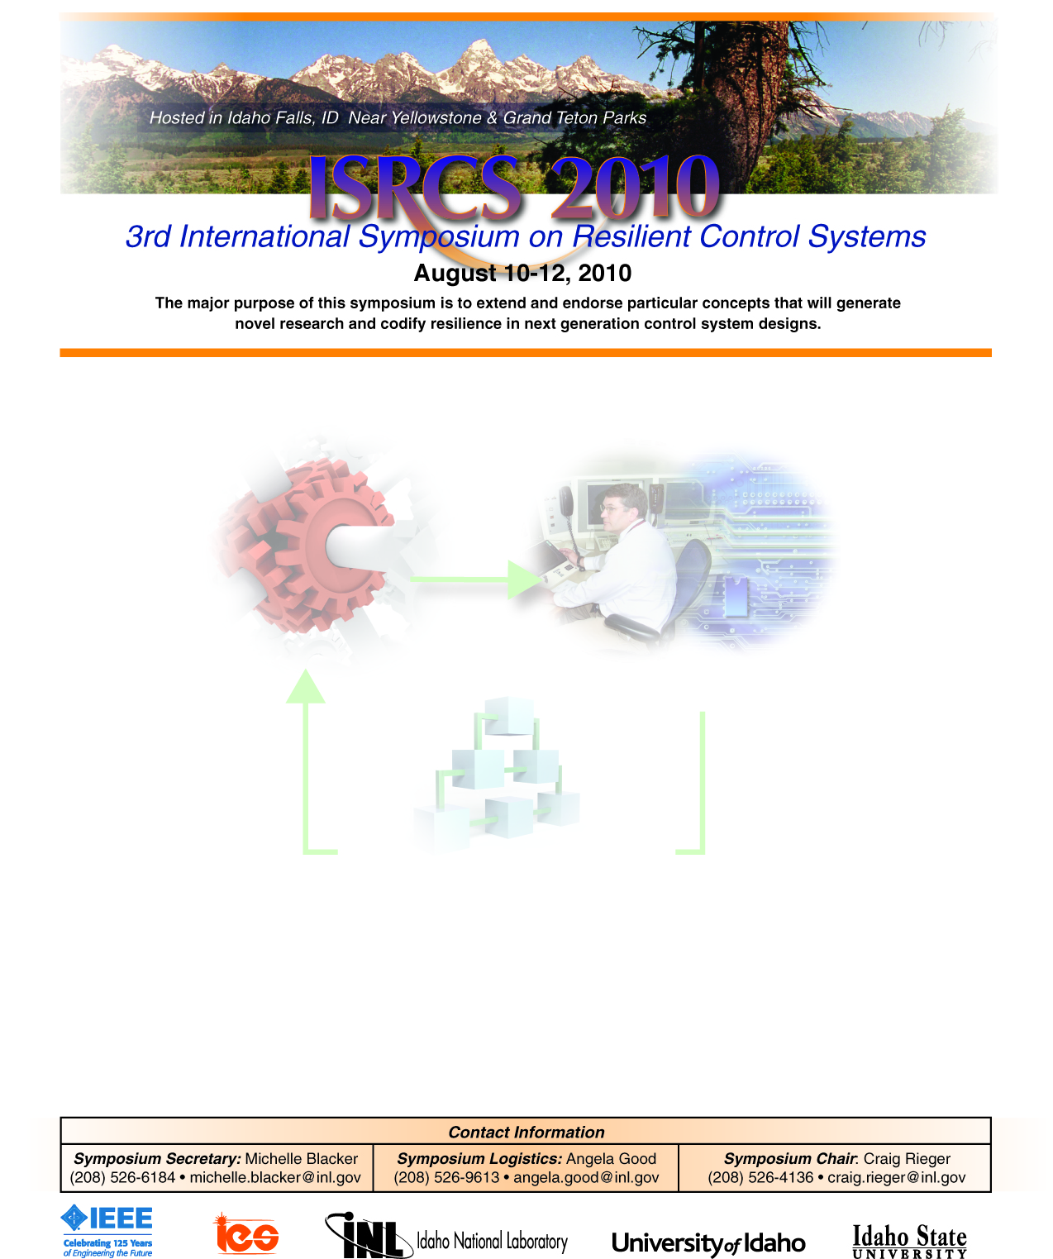
Special/Invited Session Announcement & Call for Papers
Session S/I-XX: Resilient Vehicle Coordination Over Sensing & Communication Networks.
Session Abstract: Numerous examples studying vehicle coordination problems such as those which address effective vehicle deployment and rendezvous problems abound in the literature. Typically, these problems either: i) assume communication of individual position and/or velocity information over networks in order to maintain spacing amongst neighbors or ii) assume that each vehicle can sense relative position and/or velocity measurements amongst their immediate neighbors. Papers which rely on communication networks can typically achieve faster convergence rates than those which rely on only local sensing information. However the decentralized approaches which rely on local sensing information are not prone to networked attacks. Attacks on communication networks can include: i) standard denial of service (DOS) attacks which introduce time delay and data loss; or ii) more sophisticated man in the middle (MITM) attacks; for example. MITM attacks are considerably worrisome because they can negate sensor information and potentially destabilize the entire vehicle formation. Resilient vehicle coordination is concerned with: i) specifically identifying types of attacks which can adversely affect given group coordination control problems (DOS, MITM) ii) clearly identifying how performance will degrade (system becomes unstable, collisions occur, etc.) iii) identifying potential countermeasures and control structures (combine networked control solutions with decentralized control approaches) which can better withstand a given attack/ system fault iv) developing improved network attack/ fault detection algorithms.
Topics: Resilient vehicle deployment, resilient vehicle rendezvous and other related coordination problems are of interest. In particular approaches which attempt to formally handle networked and local sensing information in an effective manner are of interest. All vehicle coordination problems such as those involving ground, aerial, space, and under-water vehicles are of interest.
Chairs:
- Nicholas Kottenstette (ISIS, Vanderbilt University) nkottens@isis.vanderbilt.edu
- Gabor Karsai (ISIS, Vanderbilt University) gabor.karsai@vanderbilt.edu
Authors’ Schedule:
- Paper submission deadline: April 5, 2010
- Notification of acceptance: June 7, 2010

Chairs:
- Nicholas Kottenstette (ISIS, Vanderbilt University) nkottens@isis.vanderbilt.edu
Authors’ Schedule:
- Paper submission deadline: April 5, 2010
- Notification of acceptance: June 7, 2010
- Final Paper Submission: July 12, 2010

Submission of Papers:
Papers must be submitted electronically through the electronic submission system. For further details please consult the conference web pages for the paper template.

